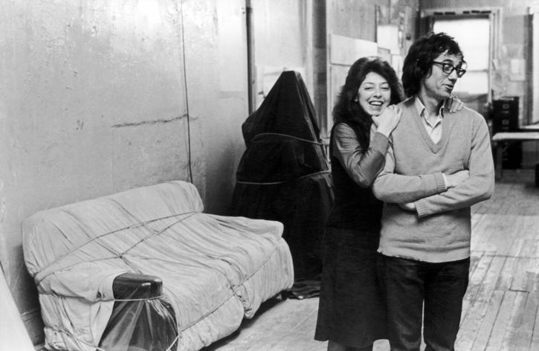
Christo
and
Jeanne-Claude
Environmental
Works of Art
Resources

1. christojeanneclaude.net
2. gwarlingo.com/2012/found-christo-and-jeanne-claudes-the-valley-curtain
3. articles.latimes.com/2009/nov/20/local/la-me-jeanne-claude20-2009nov20
Biography

Christo and Jeanne-Claude are an artist couple who collaborated on installation art and environmental works of art since they met in 1958. They were both born on June 13, 1935, Christo in Bulgaria, Jeanne-Claude in France. They had their only son, Cyril, in 1960. In 2009, Jeanne-Claude passed away due to complications from a brain aneurysm.

They are famous for wrapping buildings and other large objects in fabric. All of their environmental works of art are large-scale, typically involving hundreds of workers and vast amounts of materials. They fund all of their works themselves, in order to ensure artistic freedom.

Although much of their work may have political or social meaning to onlookers, the artists insist that they create art simply for the beauty and joy of it. Their installations are always short-lived. Their explanation for this is that beauty is something enjoyed best in the moment. People take for granted objects that are constant. However, if its life is short, like a rainbow, then there is an urgency to see it.

Even after Jeanne-Claude's death, Christo is still working; he currently has plans to bring their last two collaborations to realization. Over the River will, if realized, cover the Arkansas River in Colorado with fabric panels. Although the project has met with resistance from local government and environmental groups, he has support from many who believe the project would boost tourism in the area. If realized, the last Christo and Jeanne-Claude collaboration would be The Mastaba. A geometrical structure made of hundreds of thousands of oil barrels, The Mastaba is planned to be built in the desert of Abu Dhabi, in Al Gharbia.
Sketch Your Ideas!
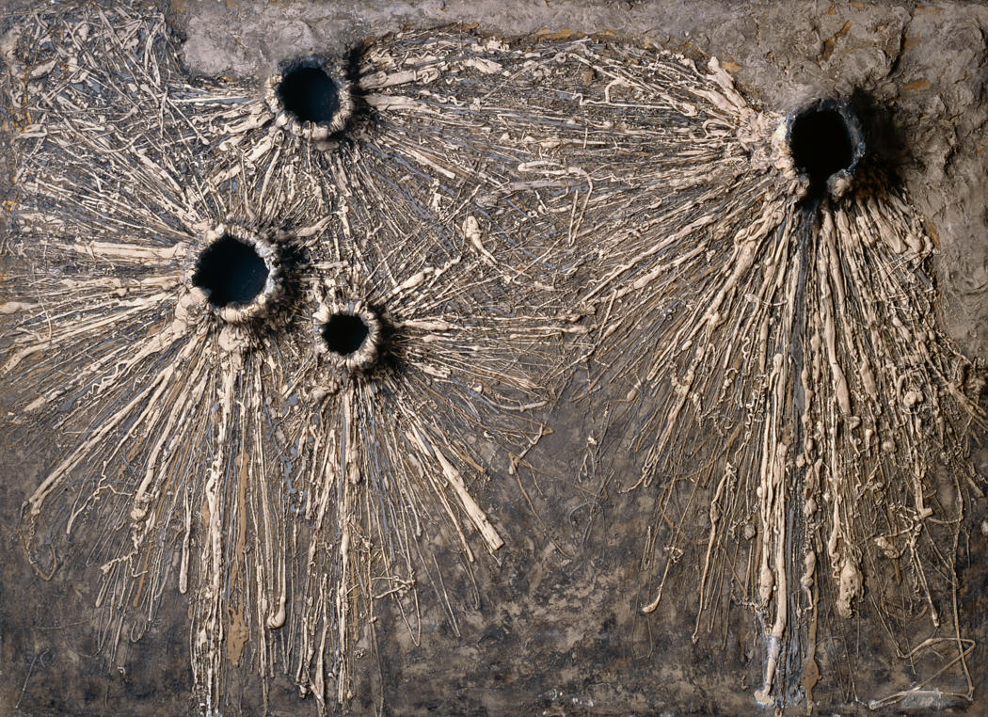
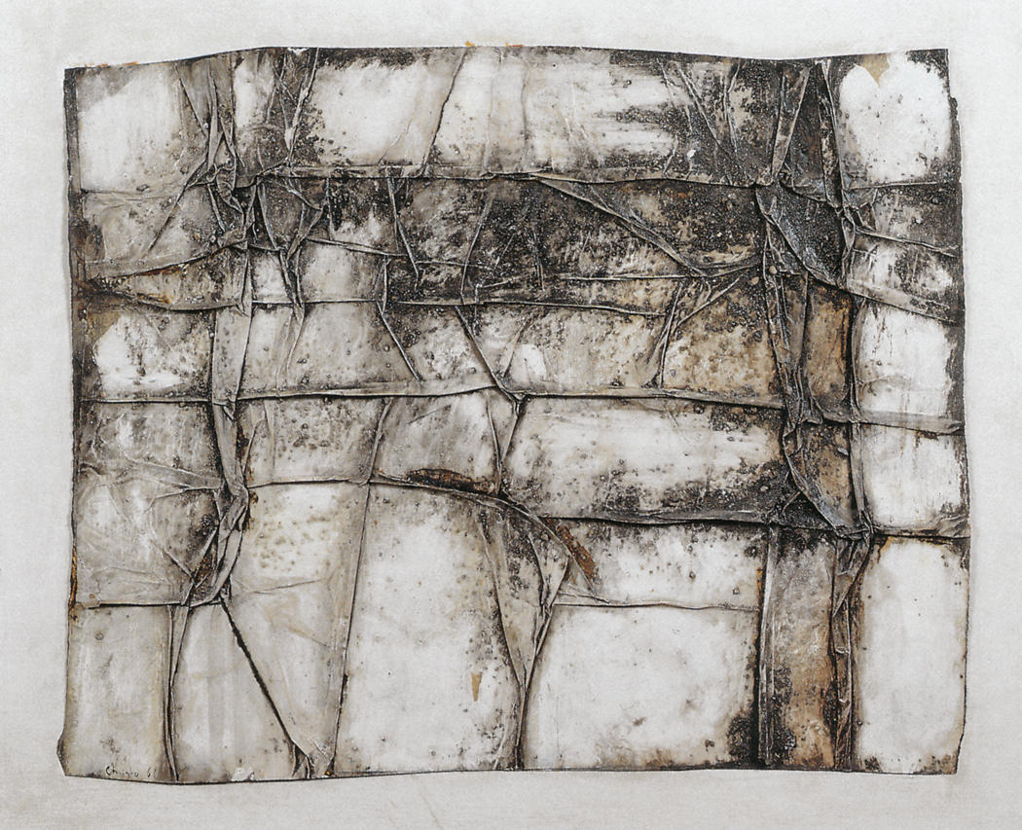
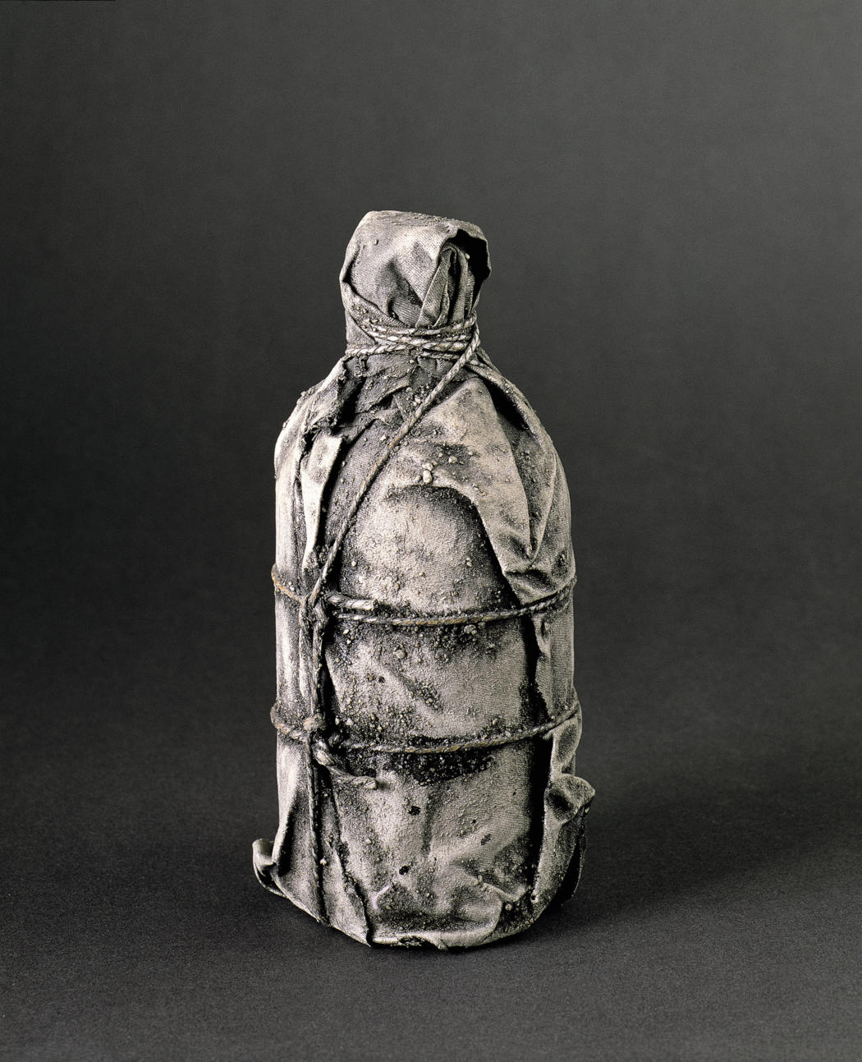
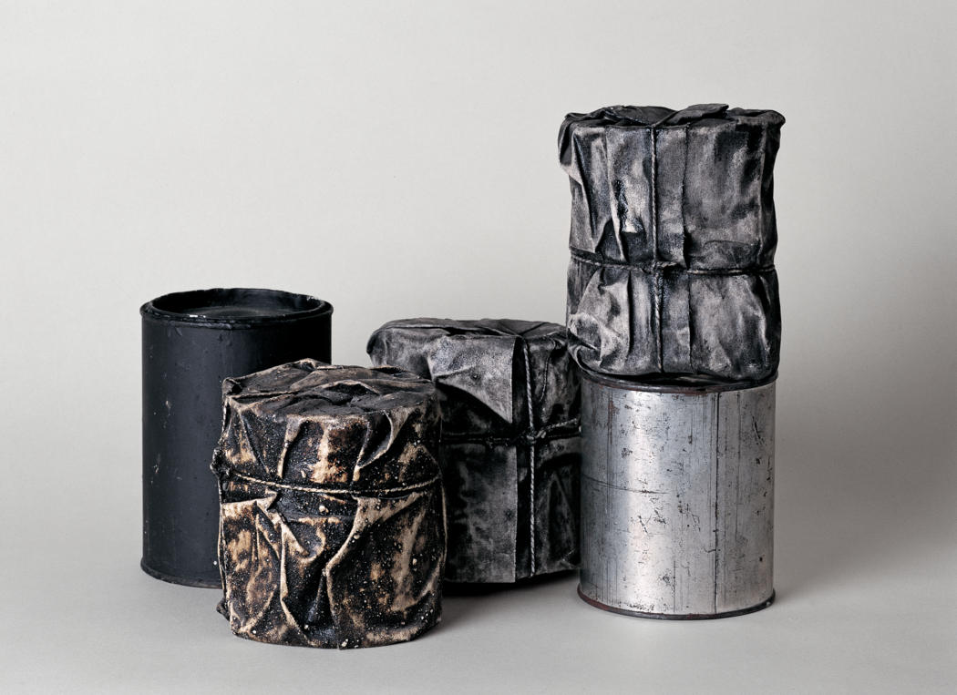
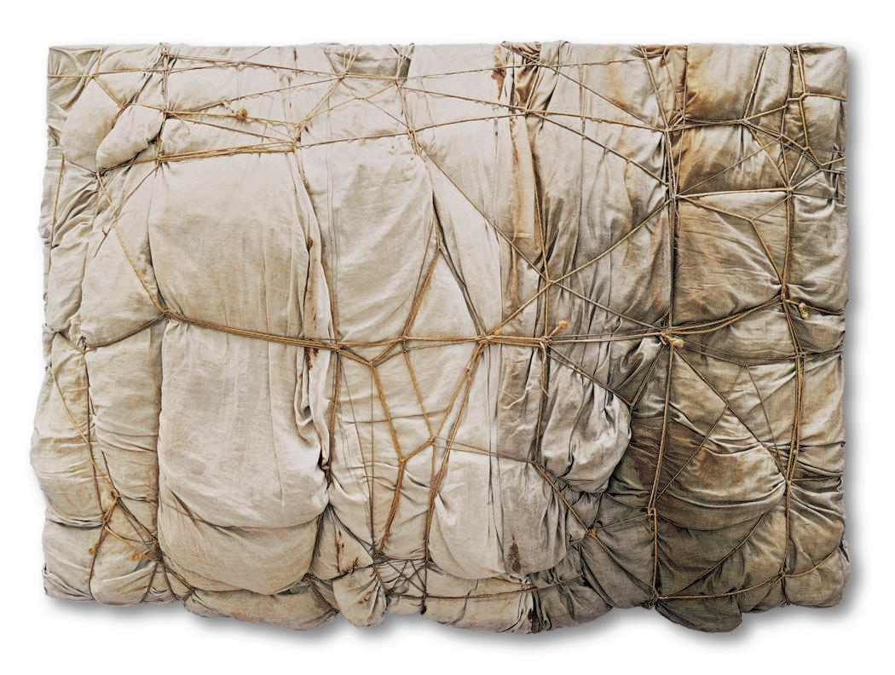
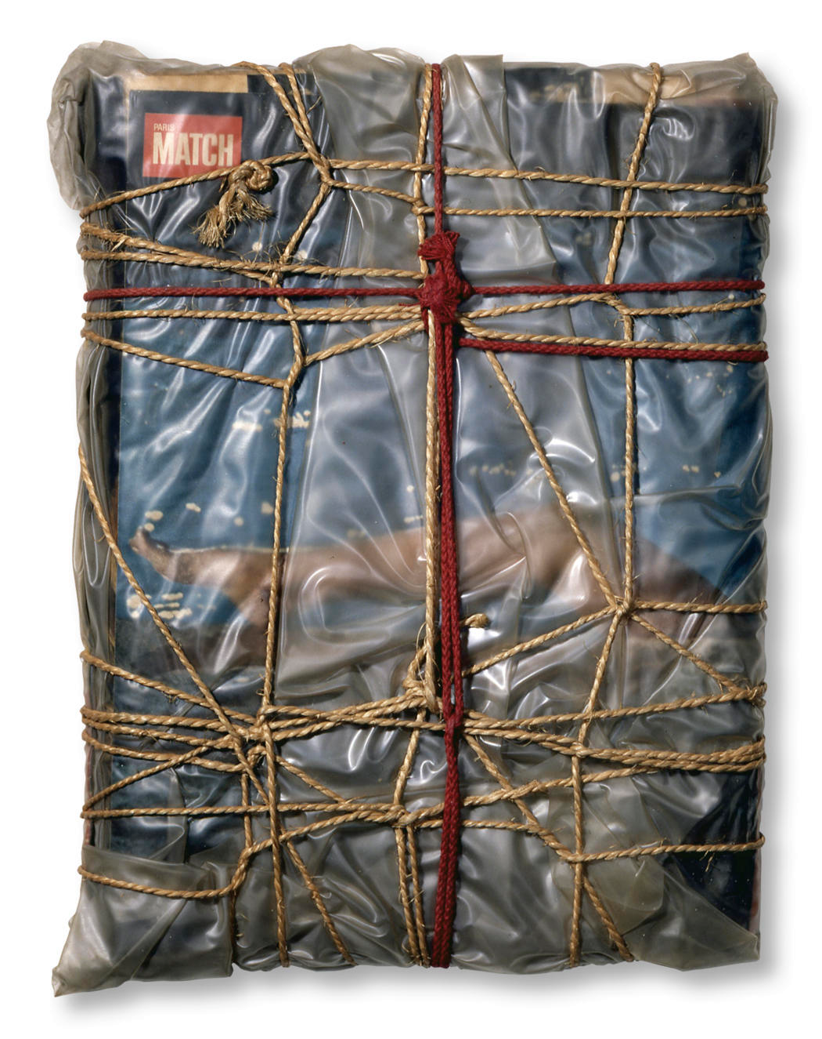
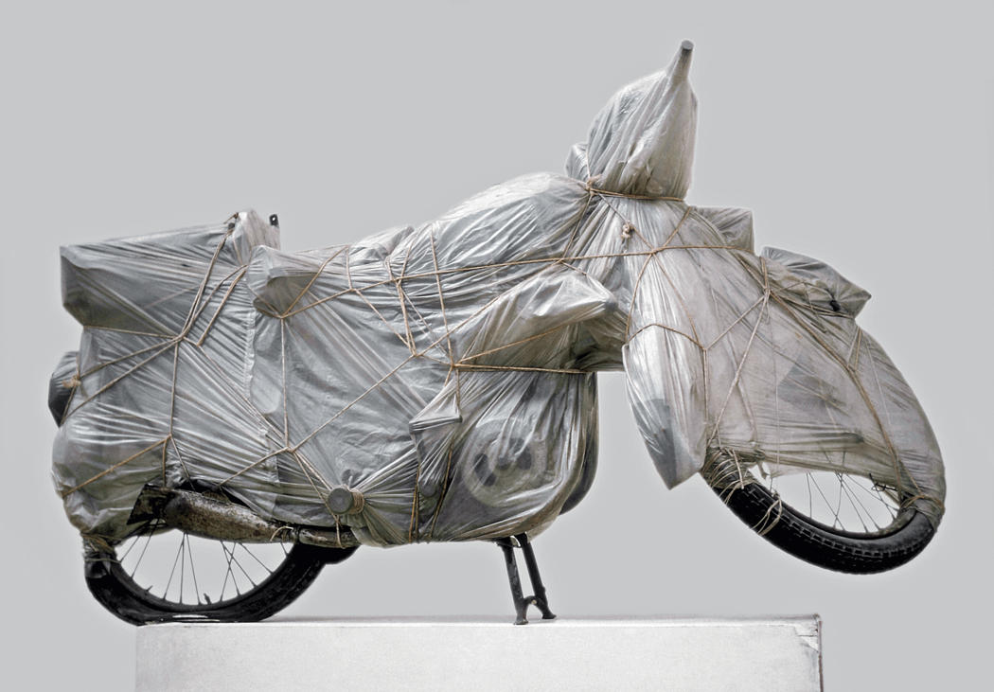
Wrapped Objects
Project Instructions
Think about some objects you have at home, or take a look at some of the objects we have available in class. List some things that you would think would be fun to wrap:
1. _______ 4. _______
2. _______ 5. _______
3. _______ 6. _______
Now it's time to plan your project. Either take an object from the box here in class, or find one at home. Try to envision what your chosen object will look like when wrapped with different materials. Consider different fabrics, paper, string, etc.

Using the space on the next page, sketch a couple different ideas. Be sure to think about what the object will look like from all different angles. Try different ways to drape and fold the fabric to accentuate the contours and features of your object.

Once you've planned out what you want to do, you can wrap your object. Bring it to class to share tomorrow. We will photograph and disassemble the objects together.
Early Works

Even as a young man, Christo showed an interest in three-dimensional art. His early paintings explore textures, often exhibiting large holes, drips, and thick layers of paint covering objects underneath.
Christo's fascination with wrapping objects began shortly after he met Jeanne-Claude in Paris, where he created many wrapped bottles, cans, and other items. After the couple moved to New York in 1964, many of these works were lost when their landlord threw them in the trash.
Much of Christo's early work relied heavily on the concept of wrapping and packaging. This element was carried out in larger works that were realized much later.
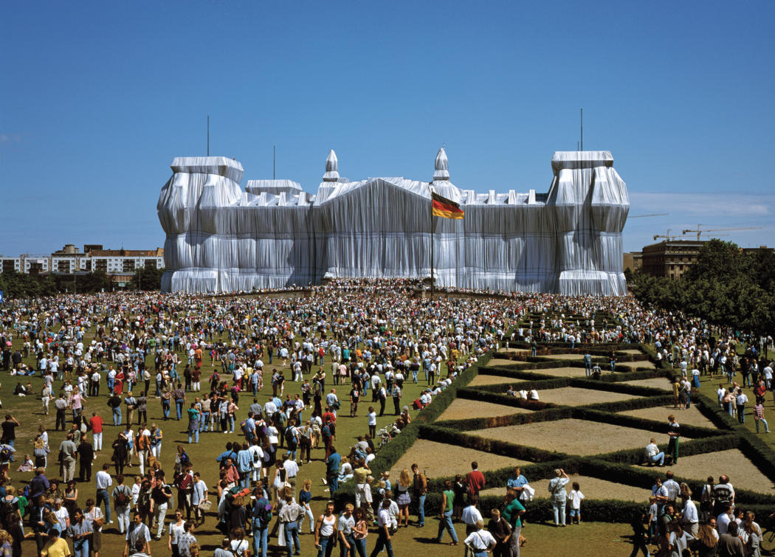
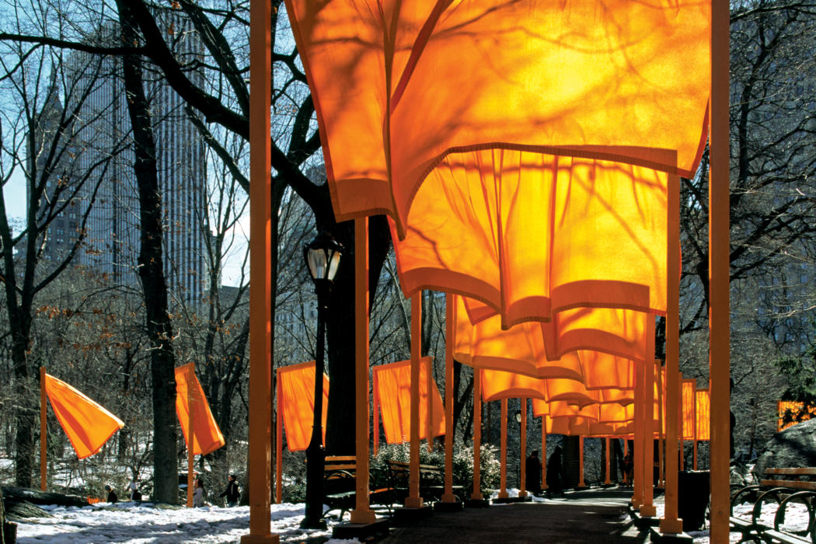
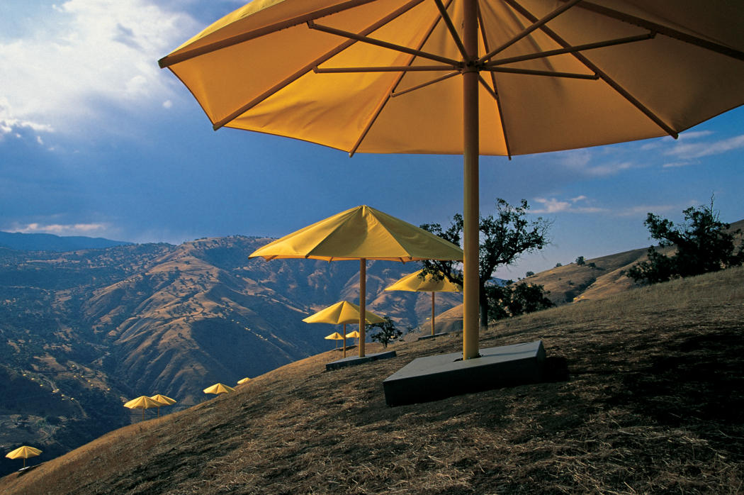
Environmental
Works of Art

Christo and Jeanne-Claude came up with the idea for large-scale environmental works of art very early in their career, beginning in the 1960s. However, these project took decades to bring to life. Some have yet to be realized even today.

These projects take years of planning. After planning out locations and materials, and drawing precise plans for these projects, there is still a lot of work that needs to be done. The process involves getting permission from the proper authorities, usually local government and property owners; getting permits; manufacturing materials; hiring work crews; planning for disassembly and disposal of materials. It is an amazing feat that any of these projects ever got done!
Interesting Facts

Wrapped Reichstag
Berlin, Germany
▪ 1971-1995
▪ 90 climbers
▪ 120 workers
▪ 1,076,390 sq. feet polypropylene fabric
▪ 9.7 miles blue polypropylene rope
▪ Lasted 14 days

The Umbrellas
California and Japan
▪ 1984-1991
▪ 2,000 workers
▪ 3,100 total umbrellas
▪ $26 million, funded entirely by Christo and Jeanne-Claude
▪ 1,340 Blue umbrellas span 12 miles in Ibaraki, Japan
▪ 1,760 Yellow umbrellas span 18 miles in the Tejon pass, CA
▪ Lasted 18 days
▪ All materials were recycled after disassembly

The Gates
Central Park, New York
▪ 1979-2005
▪ 7,503 "Gates"
▪ 23 miles of walkway
▪ 16 feet tall
▪ Approx. 7 feet of space to walk underneath
▪ 600 workers to install, 300 to take down
▪ Extra security in the park at night
▪ Lasted 16 days
▪ All Materials were recycled after disassembly

